Miniproject_timeseries.R

sumedh

Sun Jul 01 20:26:23 2018

Missing value in item A ( graph plotted in the excel)

Missing Value

Missing value in item A ( graph plotted in the excel)

Missing Value

rm(list=ls())  
# Set Working Directory   
setwd("D:/Great Lakes PGPDSE/Great Lakes/12 Time Series Forecasting/Mini Project")  
#Read Data file in CSV format  
# first row is deleted from data in excel and from excel format conveted into the csv format  
# plotted the graph in the excel for item a and item b  
demand=read.csv("DemandAB.csv")  
head(demand)

## year month itema itemb  
## 1 2002 1 1954 2585  
## 2 2002 2 2302 3368  
## 3 2002 3 3054 3210  
## 4 2002 4 2414 3111  
## 5 2002 5 2226 3756  
## 6 2002 6 2725 4216

summary(demand)

## year month itema itemb   
## Min. :2002 Min. : 1.000 Min. :1954 Min. :1153   
## 1st Qu.:2005 1st Qu.: 3.000 1st Qu.:2743 1st Qu.:2358   
## Median :2009 Median : 6.000 Median :3114 Median :2869   
## Mean :2009 Mean : 6.406 Mean :3251 Mean :2957   
## 3rd Qu.:2013 3rd Qu.: 9.000 3rd Qu.:3729 3rd Qu.:3460   
## Max. :2017 Max. :12.000 Max. :5725 Max. :5618   
## NA's :1 NA's :1

# Total 187 observation with 4 Variables.  
View(demand)  
# 4 variables names is year , Month , item a and item b  
# 2 missing values is there one in item a and other one in item b  
# in item a missing value is at Dec 2011  
# in item b missing value is at Sep 2005  
str(demand)

## 'data.frame': 187 obs. of 4 variables:  
## $ year : int 2002 2002 2002 2002 2002 2002 2002 2002 2002 2002 ...  
## $ month: int 1 2 3 4 5 6 7 8 9 10 ...  
## $ itema: int 1954 2302 3054 2414 2226 2725 2589 3470 2400 3180 ...  
## $ itemb: int 2585 3368 3210 3111 3756 4216 5225 4426 3932 3816 ...

# for na value treatment import imputeTS package and missing value treatment   
library(imputeTS)  
# On the basis of na.interpolation  
a=ts(demand[,3],start = c(2002,1),frequency = 12)  
demand$itema=na.interpolation(a,option="spline")  
b=ts(demand[,4],start=c(2002,1),frequency=12)  
demand$itemb=na.interpolation(b,option = "spline")  
  
  
#For Item A there is a overall increase in the seasonality from January to August after that decrease then again increase.  
  
#For Item B is a overall decrease in the seasonality from January to October after that there is a increase in the seasonality for Nov and Dec.   
  
  
#View(demand)  
# item a plot and time series  
itema <- ts(demand[,3], start=c(2002,1), frequency=12)  
par(mfrow=c(1,2))  
plot(itema, main= "itema plot")  
# Plot for seasonality  
monthplot(itema, main="itema seasonality")

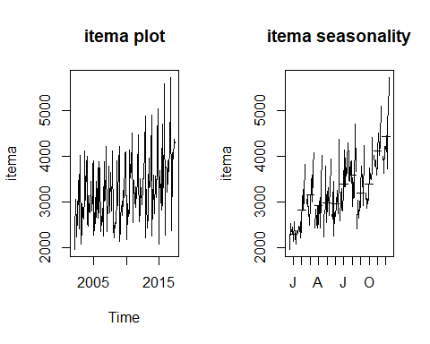

#insight from the graph  
# from this graph it is clear that there is a trend and seasonality is there  
# Graph is looks like multiplicative in nature and increasing trend and seasonality.  
# in seasonality there is high variation in the Nov. and Dec. Month.  
# for the initial period there is not much variation is there Feb to July.  
  
# item b plot and time series  
itemb <- ts(demand[,4], start=c(2002,1), frequency=12)  
par(mfrow=c(1,2))  
plot(itemb, main= "itemb plot")  
# Plot for seasonality  
monthplot(itemb, main="itemb seasonality")

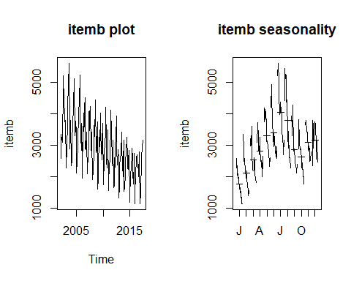

# insight from the graph   
# it is a multiplicative in nature   
# there is a descreasing trend ad Seasonality.  
# For each month Jan to June there is a descreasing seasonality   
# In the month of July and August there is a high seasonality is there.  
# Season variation are changing across year.  
  
# Seasonality plot for Item A and B plot for seasonality and the not trend  
par(mfrow=c(1,2))  
monthplot(itema,main="item A Seasonality plot")  
monthplot(itemb,main="item B Seasonality plot")

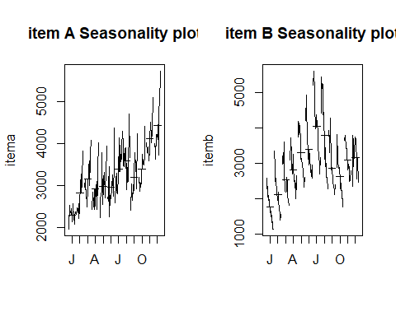

# For Item A monthplot graph interpretatation  
# Here item A is showing a seasonality but not sure whether there is a trend or not.   
# It is showing properties of addictive series till 2010, but after 2010 it is showing more variance and showing some positive trend.  
# So item A can be considered as multiplicative series.  
# Here the average values for months February to August is almost same. But in November and December it increases and reaches the peak. Also the graph is showing some variances in most of the months. It showing highest variation in December. Also it has some overall increasing demand .  
  
# For item B monthplot graph interpretation  
#Item B is showing both seasonality and negative trend.   
#Here the Item B follows multiplicative series.  
#Here the averages are increasing from January and reaches the peak at june and again reduces. Here in june, july and august the demand for B is high. But it have a high variance in all the months. From the graph it is clear that the demand for B is reducing over years.  
  
  
# Analysis of a multiplicative series for item a  
# considering item a as multiplicative  
logitema <- log(itema)  
itemadec <- stl(logitema,s.window="p")  
plot(itemadec)

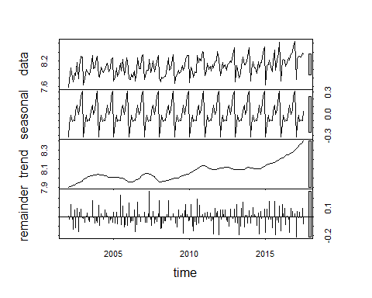

# trying with window width 3 in item a  
itemadec1 <- stl(logitema,s.window=3)  
plot(itemadec1,main="Decompose of item a")

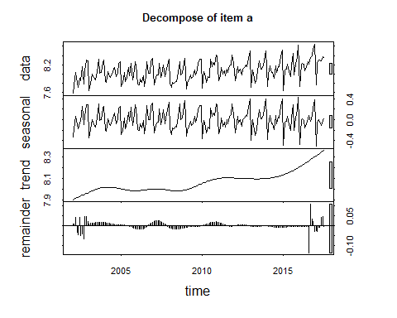

# there is 2 residual near to the end which is not much concern to me beacuse remainder < trend+seasonality   
# there is a increasing trend   
# Compare to constant window width "p" now with window size = 3 residual has been reduced.  
# After 2012 there is increase in seasonality variation in the data.  
# From the addictive decomposition plot we can see that seasonality component have more importance than trend and reminder is much less compared to trend and seasonality.  
plot(itemadec1$time.series[,2],main='TREND FOR DEMAND A YEARLY WISE',col='red') ## trend  
  
plot(itemadec1$time.series[1:12,2],main='TREND FOR DEMAND A MONTHLY WISE',col='BLUE',type='l')

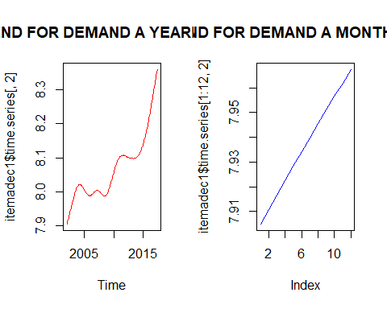

#Conclusion: There is an overall increase in trend for the demand A from the year 2002 to 2017.It means that the demand for the consumable item A increases over the period of time.  
  
plot(itemadec1$time.series[,1],ylab='DEMAND_A_SEASONALITY',col='pink')  
#In which month(s) do you see higher sales and which month(s) you see lower sales for Demand A?  
#Ans) Heigher Sales - DECEMBER (Average Demand Around 4400)  
#Lower Sales - JANUARY (Average Demand Around 2300)  
  
# item a decompose season with seasonality and trend of item a  
   
itemadseason <- exp(itemadec1$time.series[145:187,1])  
plot(itemadseason,type="l", main="item a with two series Seasonality separately")

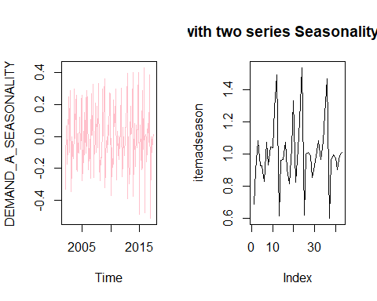

# item a decompose season with seasonality of item a  
itemadtrend <- exp(itemadec1$time.series[145:187,2])  
plot(itemadtrend,type="l", main="item a with two series trend separately")  
  
# for itemadseason and itemadtrend form 2014 Jan till 2017 July  
par(mfrow=c(1,2))

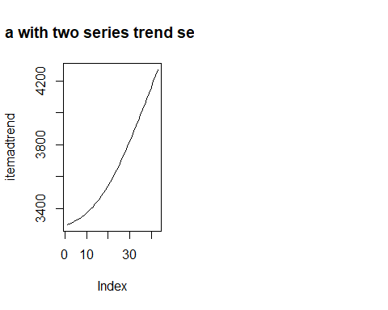

plot(itemadseason,type="l", main="item a with two series Seasonality separately")  
plot(itemadtrend,type="l", main="item a with two series trend separately")

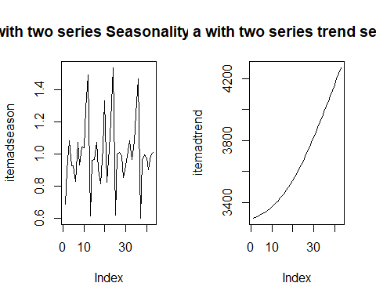

# from the above plot it is clear that graph of trend is increasing   
# there is a high seasonal variation during the month of Nov. and Dec.   
  
# item a decompose season with seasonality and trend of item b  
  
# Analysis of a multiplicative series for item b  
# considering item a as multiplicative  
logitemb <- log(itemb)  
itembdec <- stl(logitemb,s.window="p")  
plot(itembdec)

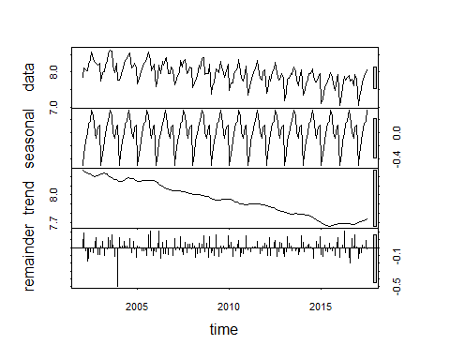

# trying with window width 3 in item b  
itembdec1 <- stl(logitemb,s.window=3)  
plot(itembdec1,main="Decompose of item b")

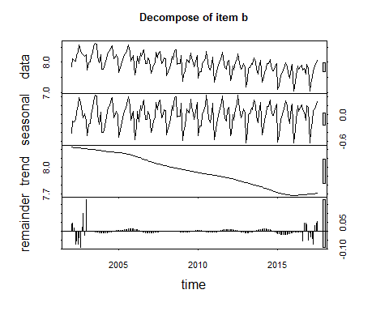

#In which month(s) do you see higher sales and which month(s) you see lower sales for Demand B(consumable item B) ?  
#Ans) Heigher Sales - JULY (Average Demand Around 4000)  
#Lower Sales - JANUARY (Average Demand Around 1800)  
  
DemandB_Seasonality<- exp(itembdec1$time.series[,1])  
plot(DemandB_Seasonality, type="l",col='red',main = 'Seasonality PLOT FOR DEMAND B Monthly Wise')  
  
# from the graph it is clear that there is a few large residual during the initial period but is it not impacting much.  
# beacuse remainder < trend + seasonality there is not much impact of the residual to the model.  
# The graph shown with the descresing trend  
# Seasonailty also descreases with after 2010.  
itemb_trend<- exp(itembdec1$time.series[,2])  
plot(itemb_trend, type="l",col='purple',main = 'TREND PLOT FOR DEMAND B Yearly Wise')

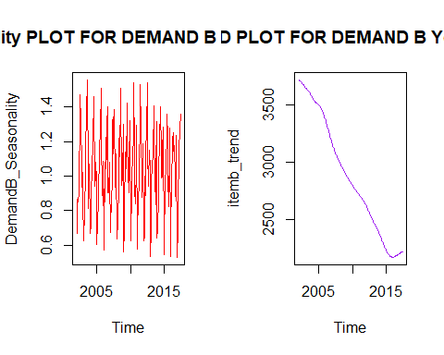

itemb_trendd<- exp(itembdec1$time.series[,2])  
plot(itemb_trendd, type="l",col='purple',main = 'TREND PLOT FOR DEMAND B Monthly Wise')  
#Conclusion: There is an overall decrease in trend for the demand B from the year 2002 to 2017 but from the year 2015(August) onwards there is slightly increase in trend .  
#It means that the demand for the consumable item B decreases over the period of time (2002 to 2015) and then demand started increasing slightly.  
  
itemb_seasonality<- exp(itembdec1$time.series[,1])  
plot(itemb_seasonality, type="l",col='red',main = 'Seasonality PLOT FOR DEMAND B Monthly Wise')

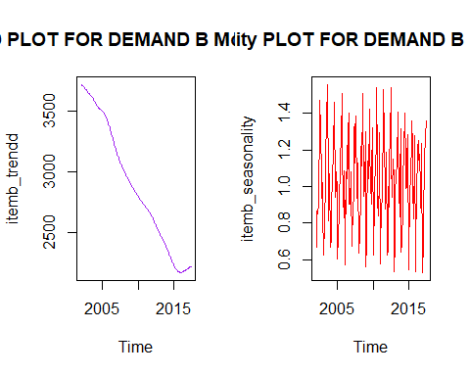

# item a decompose season with seasonality and trend of item b  
  
itemddseason <- exp(itembdec1$time.series[1:36,1])  
plot(itemddseason,type="l", main="item b with 3 series Seasonality separately")  
# Seasonality with 3 series from Jan 2002 to Dec 2004  
  
  
# item a decompose season with seasonality of item b  
itembdtrend <- exp(itemadec1$time.series[1:36,2])  
plot(itembdtrend,type="l", main="item b with 3 series trend separately")

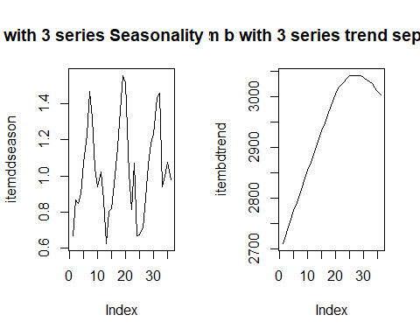

# for itemadseason and itemadtrend form 2002 Jan till 2004 Dec  
par(mfrow=c(1,2))  
plot(itemadseason,type="l", main="item a with two series Seasonality separately")  
plot(itemadseason,type="l", main="item a with two series trend separately")

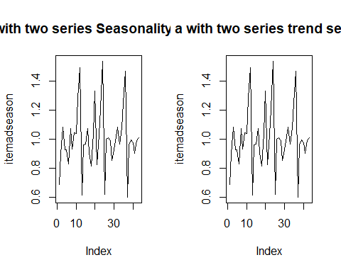

# from the above plot it is clear that graph of trend and seasonlity both are same from Jan 2014 to July 2017  
library(forecast)  
 #checking for moving average item a   
  
#  
# moving average with window width 17 showing the smooth curve for item A  
itema7 = ma(itema, order = 7)  
itema9 = ma(itema, order = 9)  
itema13 = ma(itema, order = 13)  
itema17 = ma(itema, order = 17)  
itema21= ma(itema,order=23)  
ts.plot(itema,itema7,itema9,itema13,itema17,itema21,lty=c(1:6),  
col=c('black','red','green','blue','yellow','brown'), main = "TS plot for item A Moving average ")  
  
# checking for moving average itme b  
itemb7 = ma(itemb, order = 7)  
itemb9 = ma(itemb, order = 9)  
itemb13 = ma(itemb, order = 13)  
itemb17 = ma(itemb, order = 17)  
itemb21= ma(itemb,order=23)  
ts.plot(itemb,itemb7,itemb9,itemb13,itemb17,itemb21,lty=c(1:6),  
col=c('black','red','green','blue','yellow','brown'),main = "TS plot for item B Moving average ")

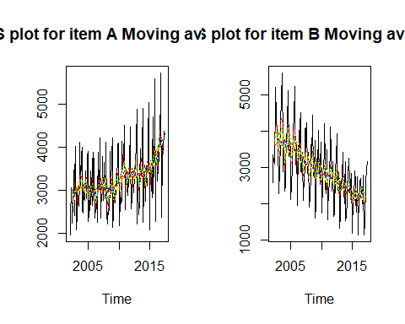

# moving average with window with 9 optimal compares to others.  
  
#Now considering item A as multiplicative Series  
mitema<-decompose(itema, type = "m")  
plot(mitema)

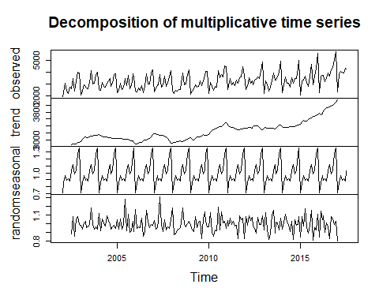

mitema$figure

## [1] 0.7115622 0.8587972 0.9568689 0.8878002 0.9165263 0.8863776 1.0266169  
## [8] 1.1166486 0.9788099 1.0438541 1.2653560 1.3507821

plot(mitema$figure, type = "l",main = "Seasonal Demand Item A")  
# Overall there is a increase in Seasonal graph year to year   
  
#Item B multiplicative decomposition   
#Here demand of item is multiplicative. So taking multiplicative decomposition model.  
mitemb<-decompose(itemb, type = "m")  
plot(mitemb)

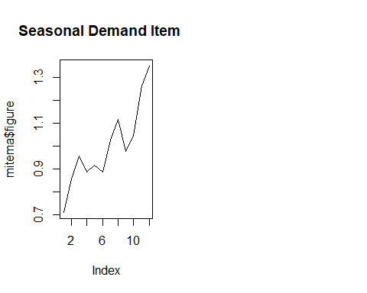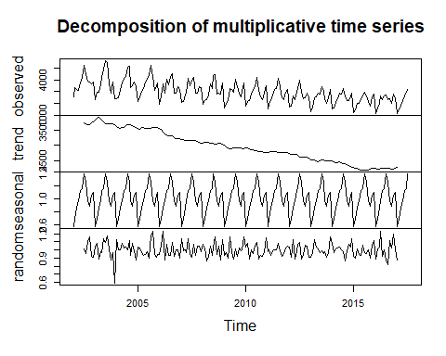

mitemb$figure

## [1] 0.5774294 0.6936458 0.8581400 0.9654911 1.1270773 1.1470453 1.3710046  
## [8] 1.2534191 0.9651239 0.8876088 1.0570549 1.0969599

plot(mitemb$figure, type = "l",main = "Seasonal Demand Item B")  
# interpretation of the item  
# From the above graph it is clear that average sales increases from January and reaches its peak at July and then decreases up to October and again raises in December. Here sales is lowest in January. For item A also sales was lowest in January. But for item B, the demand is gradually decreasing over years, from the trend graph it is clear. That is when comparing the demand of A & B we can see that the demand of item is slightly increasing in each year and demand of B gradually decreasing.  
  
#Checking the residuals for both decompositions for Item A and Item B  
plot(remainder(mitema), main = "Residuals Item A")

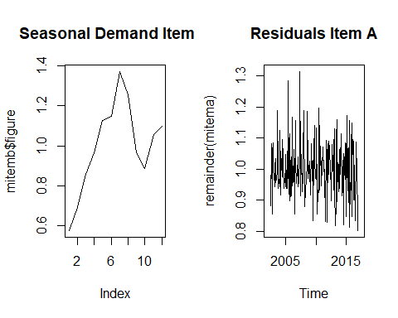

#Interpertation of the graph : Here the residuals doesn't follow any particular pattern. It suddenly increases and decreases without showing any pattern.It looks like residual is Random in nature.   
  
plot(remainder(mitemb), main = "Residuals Item B")  
#Interpertation of the graph : Residuals of B also not showing any pattern and it doesn't have much contribution in the entire time series model.There is asudeen dip in the residual before 2005.Residual is moving under specific band approx 08 to 1.2 values.  
  
# Dividing a time series into train and test  
  
# For item A (Dividing a time series into train and test)  
atrain <- window(itema, start=c(2002,1), end=c(2015,10),frequency=12)  
atest <- window(itema, start=c(2015,11),frequency=12)  
#Made last 21 months data for testing purpose.  
  
# For item B (Dividing a time series into train and test)  
btrain <- window(itemb, start=c(2002,1), end=c(2015,10),frequency=12)  
btest <- window(itemb, start=c(2015,11),frequency=12)  
#Made last 21 months data for testing purpose.  
  
#Considering item A and item B both as multiplicative model  
  
# Among all three method 1) Simple exponential smoothing model(ses) , 2) holt ( Double Exponential Smoothing model) , 3) Holt Winter model  
# Hotl Winter model gives the better results beacuse it have three smoothing parameters   
# aplha = level/ randomness/ residuals / remainders  
# beta= trends in the model  
# gamma= seasonality in the model  
# So alpha beta and gamma helps to decide the smoothness of the model.  
  
#SIGNIFICANCE OF THE FOLLOWING PARAMETER IN MODELLING:  
  
# Alpha= for the estimate of the level at the current time point .  
#Value of smoothing parameter for the level.  
#Beta= for the estimate of the slope b of the trend component at the current time point  
#Value of smoothing parameter for the trend.  
#Gamma= Value of smoothing parameter for the seasonal component.  
  
# So Holt winter model covers the all three smoothing parameters and gives better results copares to the others.  
atrain.fc = hw(atrain, seasonal = 'm', h=21)# forecast for 21 periods  
atrain.fc

## Point Forecast Lo 80 Hi 80 Lo 95 Hi 95  
## Nov 2015 4441.409 3844.388 5038.430 3528.344 5354.474  
## Dec 2015 4677.804 4045.046 5310.561 3710.085 5645.522  
## Jan 2016 2565.589 2216.239 2914.939 2031.304 3099.874  
## Feb 2016 2990.838 2580.731 3400.944 2363.634 3618.042  
## Mar 2016 3408.614 2937.786 3879.442 2688.544 4128.683  
## Apr 2016 3108.440 2675.770 3541.109 2446.728 3770.151  
## May 2016 3217.781 2766.292 3669.269 2527.289 3908.272  
## Jun 2016 3155.289 2708.863 3601.715 2472.540 3838.039  
## Jul 2016 3647.782 3127.186 4168.377 2851.600 4443.964  
## Aug 2016 4000.988 3424.835 4577.141 3119.838 4882.138  
## Sep 2016 3477.934 2972.429 3983.438 2704.831 4251.036  
## Oct 2016 3714.885 3169.739 4260.031 2881.157 4548.614  
## Nov 2016 4513.484 3844.564 5182.405 3490.459 5536.510  
## Dec 2016 4753.613 4041.912 5465.313 3665.160 5842.065  
## Jan 2017 2607.111 2212.689 3001.533 2003.895 3210.328  
## Feb 2017 3039.177 2574.450 3503.904 2328.438 3749.916  
## Mar 2017 3463.631 2928.179 3999.084 2644.727 4282.536  
## Apr 2017 3158.545 2664.773 3652.316 2403.386 3913.703  
## May 2017 3269.579 2752.594 3786.563 2478.919 4060.238  
## Jun 2017 3206.013 2693.164 3718.862 2421.678 3990.348  
## Jul 2017 3706.345 3106.422 4306.267 2788.842 4623.847

plot(atrain.fc)

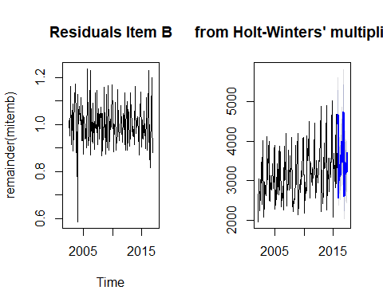

names(atrain.fc)

## [1] "model" "mean" "level" "x" "upper"   
## [6] "lower" "fitted" "method" "series" "residuals"

# for cehcking the Holt winter odel parameters   
atrain.fc$model

## Holt-Winters' multiplicative method   
##   
## Call:  
## hw(y = atrain, h = 21, seasonal = "m")   
##   
## Smoothing parameters:  
## alpha = 0.108   
## beta = 0.004   
## gamma = 1e-04   
##   
## Initial states:  
## l = 2977.3536   
## b = 17.6554   
## s = 1.3316 1.266 1.0434 0.9781 1.1267 1.0286  
## 0.891 0.9098 0.8801 0.9664 0.8491 0.7293  
##   
## sigma: 0.1049  
##   
## AIC AICc BIC   
## 2789.419 2793.554 2842.323

# from this model alpha, beta and gamma value is given below  
#Smoothing parameters:  
#alpha = 0.108   
#beta = 0.004   
#gamma = 1e-04  
  
Vec<- cbind(atest,atrain.fc$mean)  
ts.plot(Vec, col=c("blue", "red"), main="Monthly Sales of A: Actual vs Forecast")  
  
# Calculating the MAPE  
MAPE <- mean(abs(Vec[,1]-Vec[,2])/Vec[,1])  
MAPE # MAPE for this model is coming up with 13.67%

## [1] 0.1367863

# Checking for the second model on atest data ( second model)  
atrain.fc1 = hw(atrain, seasonal = 'm',h=21,alpha=0.09,beta=0.04,gamma=0.3)  
# for this holt winter model  
# alpha =0.09  
# beta=0.04  
# gamma=0.3  
plot(atrain.fc1)# dark shawdow show 80 % C.I and lighter shawdow show 95% C.I.

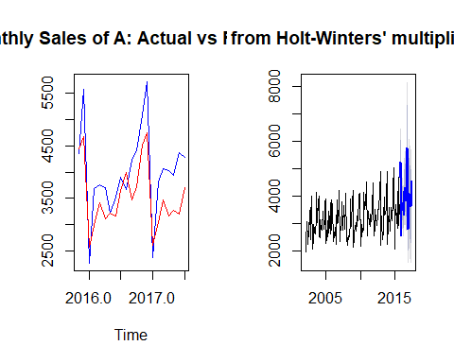

Vec1<- cbind(atest,atrain.fc1$mean)  
ts.plot(Vec1, col=c("blue", "red"), main="Monthly Sales of Item A: Actual vs Forecast")  
# this plot shows that Actual and forecast are overlapping to each other there is hardly difference between actual and forecasted value.  
MAPE <- mean(abs(Vec1[,1]-Vec1[,2])/Vec1[,1])  
  
MAPE # MAPE 6.68% which descrease from 13.67% which shows there is reduction in the error from the first( inital model)

## [1] 0.06681451

#Applying holt winters method,  
btrain.fc = hw(btrain, seasonal = 'm',h=21)  
btrain.fc

## Point Forecast Lo 80 Hi 80 Lo 95 Hi 95  
## Nov 2015 2317.773 2018.462 2617.083 1860.0170 2775.528  
## Dec 2015 2353.705 2049.667 2657.744 1888.7188 2818.692  
## Jan 2016 1316.207 1146.132 1486.283 1056.0993 1576.315  
## Feb 2016 1582.864 1378.258 1787.469 1269.9458 1895.781  
## Mar 2016 1854.363 1614.566 2094.161 1487.6249 2221.102  
## Apr 2016 2030.964 1768.213 2293.716 1629.1203 2432.808  
## May 2016 2442.816 2126.626 2759.005 1959.2460 2926.385  
## Jun 2016 2487.647 2165.481 2809.812 1994.9372 2980.356  
## Jul 2016 2998.014 2609.524 3386.504 2403.8703 3592.158  
## Aug 2016 2791.909 2429.894 3153.924 2238.2554 3345.563  
## Sep 2016 2062.777 1795.119 2330.435 1653.4290 2472.124  
## Oct 2016 1916.149 1667.329 2164.969 1535.6112 2296.687  
## Nov 2016 2196.971 1911.450 2482.492 1760.3048 2633.638  
## Dec 2016 2230.496 1940.363 2520.630 1786.7751 2674.217  
## Jan 2017 1247.006 1084.647 1409.365 998.6988 1495.313  
## Feb 2017 1499.276 1303.873 1694.680 1200.4321 1798.121  
## Mar 2017 1756.006 1526.892 1985.120 1405.6067 2106.405  
## Apr 2017 1922.761 1671.597 2173.926 1538.6390 2306.884  
## May 2017 2312.090 2009.693 2614.488 1849.6132 2774.568  
## Jun 2017 2353.926 2045.648 2662.205 1882.4550 2825.397  
## Jul 2017 2836.134 2464.179 3208.090 2267.2779 3404.991

plot(btrain.fc)

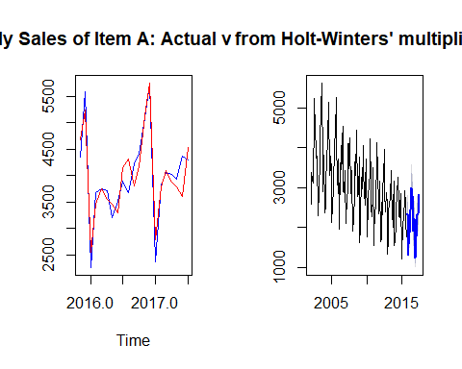

btrain.fc$model

## Holt-Winters' multiplicative method   
##   
## Call:  
## hw(y = btrain, h = 21, seasonal = "m")   
##   
## Smoothing parameters:  
## alpha = 0.0225   
## beta = 0.0013   
## gamma = 1e-04   
##   
## Initial states:  
## l = 4062.9255   
## b = -12.6305   
## s = 1.0572 1.0366 0.9 0.9645 1.2995 1.3891  
## 1.1475 1.1218 0.9285 0.844 0.7173 0.5938  
##   
## sigma: 0.1008  
##   
## AIC AICc BIC   
## 2753.599 2757.734 2806.502

#From the above model Smoothing parameters are:  
#Smoothing parameters:  
#alpha = 0.0225   
#beta = 0.0013   
#gamma = 1e-04  
  
# Plotting the graph for Item B  
Vec2<- cbind(btest,btrain.fc$mean)  
ts.plot(Vec2, col=c("blue", "red"), main="Monthly Sales of Item B: Actual vs Forecast")  
#Here the actual and forecasted data are showing bit difference. So adjustment of smoothing parameters are required.  
MAPE2 <- mean(abs(Vec2[,1]-Vec2[,2])/Vec2[,1])  
MAPE2 # 10.78% initial model MAPE is there so fine tunning is requried.

## [1] 0.1087413

# Smoothing parameter tunning of Item B  
btrain.fc1 = hw(btrain, seasonal = 'm',h=21,alpha=0.2,beta=0.13,gamma=0.17)  
plot(btrain.fc1)# from the graph it is clear that as the no. of period increases Confidence interval also increases chance of error in the forecast also increases

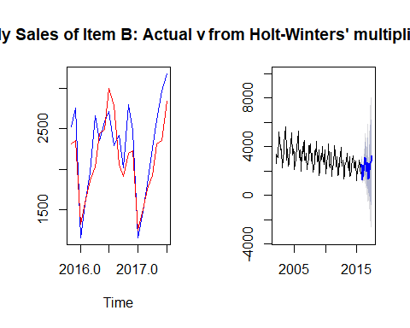

Vec3<- cbind(btest,btrain.fc1$mean)  
ts.plot(Vec3, col=c("blue", "red"), main="Monthly Sales of Item B: Actual vs Forecast")  
# As actual and forecsted is overlapped aprroximately to each other compared to the previous plot this model show good fitting of the curve.  
MAPE3 <- mean(abs(Vec3[,1]-Vec3[,2])/Vec3[,1])  
MAPE3 # 8.18% of MAPE is obtained from previous model.Earlier it was coming around 10.78%.There is a reduction in the error.

## [1] 0.08178898

# Comparison between the Actual vs Forecast for Item A and Item B  
#Here the model for item A demand gives MAPE of 6.68% and model for item B demand gives MAPE of 8.18%. Comparing the MAPE s of two models, model for item A is giving better performance. But comparing the actual v/s forecasted graphs of A and B we can find that, forecasted values of A are more equally distributed around the actual value.  
  
# Forecasting of item A with 17 periods from July 2017 to Dec 2018  
itema.fc<-hw(itema, seasonal= 'm',h=17,alpha=0.09,beta=0.04,gamma=0.3)  
itema.fc

## Point Forecast Lo 80 Hi 80 Lo 95 Hi 95  
## Aug 2017 4594.957 3915.284 5274.631 3555.486 5634.428  
## Sep 2017 4448.284 3784.852 5111.717 3433.652 5462.917  
## Oct 2017 4809.406 4082.410 5536.403 3697.561 5921.252  
## Nov 2017 5735.657 4851.733 6619.582 4383.811 7087.503  
## Dec 2017 6661.820 5608.646 7714.995 5051.129 8272.511  
## Jan 2018 2987.272 2499.855 3474.689 2241.832 3732.711  
## Feb 2018 4484.497 3725.028 5243.966 3322.990 5646.004  
## Mar 2018 4793.122 3946.413 5639.832 3498.192 6088.053  
## Apr 2018 4668.749 3804.940 5532.558 3347.668 5989.831  
## May 2018 4465.304 3597.223 5333.386 3137.689 5792.920  
## Jun 2018 4616.558 3671.338 5561.779 3170.969 6062.148  
## Jul 2018 5205.900 4081.589 6330.211 3486.415 6925.385  
## Aug 2018 5389.623 4064.568 6714.677 3363.127 7416.119  
## Sep 2018 5206.938 3864.778 6549.098 3154.281 7259.595  
## Oct 2018 5618.458 4099.254 7137.662 3295.035 7941.880  
## Nov 2018 6687.542 4790.343 8584.741 3786.027 9589.058  
## Dec 2018 7752.737 5445.520 10059.954 4224.154 11281.321

plot(itema.fc)

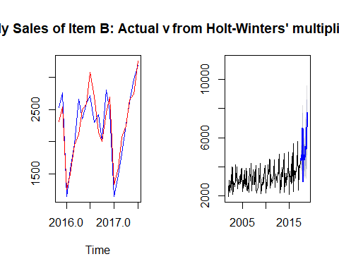

#From the graph it is clear forecasting of data from August 2017 to Dec 2018 is good beacuse there is a maximum overlap of Confidence interval of 80% and 95% .The dark shadow show 80% C.I. and light shadow show 95% C.I. and there is a maximum overlap between two which shows that it is a good forecasting model.  
# If we see the forecasting value for year Nov 2017 and Dec 2017 shows higher value for year 2017.  
# Similarly if we see the forecsting value for year Nov 2018 and Dec 2018 shows higher value for year 2018.  
# As the past data also says that there is more demand of Item A in the month of November and December in any year.  
# So as a Store manager I will plan to keep more stock of item A in November and December to meet the excess customer demand during these months.  
# In the month of Jan 2018 sales is very low we have three option 1) Give some promotional offer on item A in month of Jan. 2)Increase the sales campagin for the month of Jan. 3)Keep less stock or procure less material for Item A.  
  
  
# Forecasting of Item B.  
itemb.fc = hw(itemb, seasonal = 'm',h=21,alpha=0.2,beta=0.13,gamma=0.17)  
itemb.fc

## Point Forecast Lo 80 Hi 80 Lo 95 Hi 95  
## Aug 2017 2848.419 2355.44611 3341.391 2094.48225 3602.355  
## Sep 2017 2467.528 2018.73150 2916.324 1781.15301 3153.903  
## Oct 2017 2301.500 1848.00663 2754.993 1607.94197 2995.057  
## Nov 2017 2974.974 2324.65030 3625.297 1980.38988 3969.558  
## Dec 2017 3170.294 2390.70491 3949.882 1978.01560 4362.572  
## Jan 2018 1557.603 1124.49118 1990.715 895.21559 2219.991  
## Feb 2018 1967.946 1349.60559 2586.287 1022.27592 2913.616  
## Mar 2018 2581.231 1668.48706 3493.974 1185.30973 3977.152  
## Apr 2018 3041.907 1838.21465 4245.599 1201.01852 4882.795  
## May 2018 3464.746 1940.03685 4989.454 1132.90482 5796.586  
## Jun 2018 3737.651 1919.76932 5555.533 957.44081 6517.861  
## Jul 2018 4333.674 2017.82031 6649.528 791.88126 7875.467  
## Aug 2018 3905.216 1578.94503 6231.486 347.49180 7462.939  
## Sep 2018 3356.344 1189.44697 5523.241 42.36085 6670.328  
## Oct 2018 3107.068 941.39291 5272.744 -205.04641 6419.183  
## Nov 2018 3987.660 997.68524 6977.634 -585.11157 8560.431  
## Dec 2018 4220.632 827.55436 7613.710 -968.63264 9409.897  
## Jan 2019 2060.229 289.79750 3830.661 -647.41258 4767.872  
## Feb 2019 2586.908 217.24877 4956.567 -1037.17293 6210.988  
## Mar 2019 3373.053 87.80094 6658.305 -1651.30637 8397.412  
## Apr 2019 3952.597 -131.20791 8036.402 -2293.04366 10198.238

plot(itemb.fc)  
#From the graph it is clear forecasting of data from August 2017 to Dec 2018 is good beacuse there is a maximum overlap of Confidence interval of 80% and 95% .The dark shadow show 80% C.I. and light shadow show 95% C.I. and there is a maximum overlap between two which shows that it is a good forecasting model.  
#If we see the forecasting value for year Jan 2018 and Feb 2018 shows low values and this trend is repeated for next forecasted year and also same trend is also replicate on the historical data.  
#So as a Store Manger There is more demands of item B during July, Aug and Dec 2018 So keep the extra inventory of material during thesr periods.  
#From the forecasted data we can find that, the sales of item B is likely to go down in Jan and Feb 2018, so can plan for giving some promotional offer for item B in these month to increase the sales.  
#After Feburary sales may go up as per forecasting, so have to stock keep more stock of item B after Feburary to meet the increasing customer Demand.  
#In the month of Jan and Feb to incease the sale we have following option 1) Give Some promotion offer during this month( Jan and Feb) 2) Increase the sale campagin for the month of Jan and Feb. Keep less stock during these month ( Jan and Feb).

